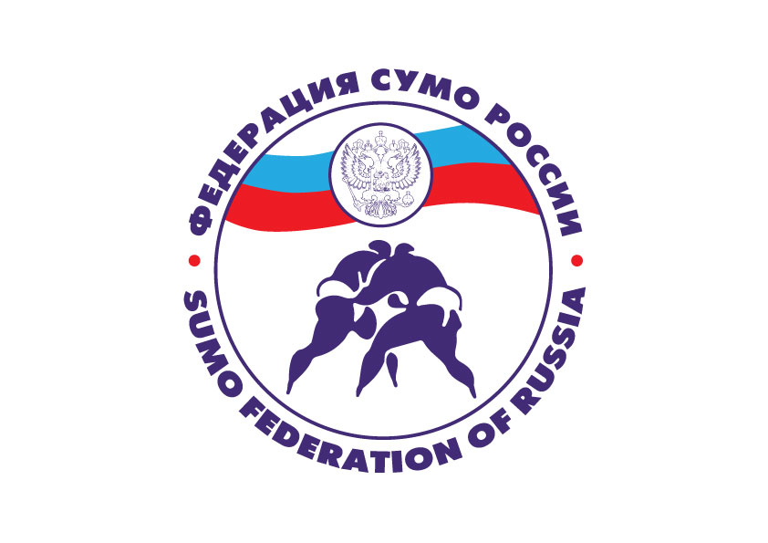

Sumo European Cup
Tournament information

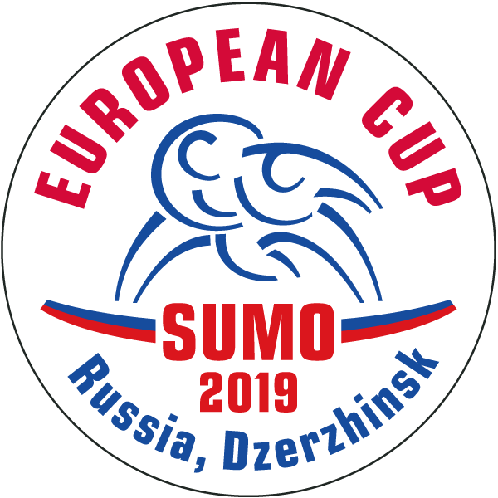

8-10, November 2019
Nizhniy Novgorod region
Dzerzhinsk
Russia

Competition Name:
Sumo European Cup 2019
Nizhniy Novgorod region, Dzerzhinsk, Russia.

Targets and goals:
- popularization and promotion of sumo at the international level;
- strengthening mutual friendship among the participating countries;
- selection for the 2021 World Games in accordance with the rating of the athlete;

Organizers:
Russian Sumo Federation
E-mail: russiansumo @ gmail.com
https://rossumo.ru/
Sumo Federation of Nizhny Novgorod Region
E-mail: sozvezdienn 2007 @ mail . ru
Co-rganizers:
Ministry of Sports of the Nizhny Novgorod Region
Dzerzhinsk city administration
Sumo Federation of Dzerzhinsk

BASIC INFORMATION

Important dates:
Application deadline | October 25, 2019
Hotel reservation deadline | October 25, 2019
Weighing | November 8, 2019
Start of competition | November 9, 2019

- Place of the competition:
"Sports complex"
Address: Nizhny Novgorod region, Dzerzhinsk, Okskaya embankment, 5a

- Application:

All documents must be executed and sent only by e-mail:
• Individual application (Application form);
• Identification photos (in jpg, pdf format);
Each photo must be a separate file, signed;
• Copy of the passport of each participant;
• Athlete data (Entry form);
• Information about the judges (Referee form).
Applications for participation are accepted until October 25, 2019,
only by e-mail russiansumo @ gmail.com

- Judges:
Judges are appointed by the Russian Sumo Federation in conjunction with the European Sumo Federation.
Applications for the participation of judges from other national teams are submitted until October 25, 2019 .
- The terms of participation:
To participate in the European Cup among men and women are allowed all Federations, members of the ESF, the age of the participants is 2002 and older.
Participants must have the nationality of the country whose federation they represent.
Admission, no more than 4 athletes from the country in each weight category.

- Accommodation and meals:
Hotel: «Druzhba»
Address: Dzerzhinsk, pl. Dzerzhinsky, 2
Accommodation (from November 8 to 10, 2019) is paid by the tournament participants.
The organizers offer the following categories of hotels:
category " D " - 20 € per person per day;
category " C " - 35 € per person per day;
category " B " - 50 € per person per day;
category "A" - 80 € per person per day;
Participants who take advantage of the organizers' offer for accommodation are provided with three meals a day.
Upon accreditation, you are given food stamps and a coupon for attending a farewell party. If you did not take advantage of the organizers' offer for accommodation, but want to get food and take part in a farewell party, you need to pay 30€ for meals and 15€ for a farewell party.
Deadline for accommodation and meals - October 25, 2019
e-mail : sozvezdienn 2007 @ mail . ru

- Entry fee: 15 €.

- Transport:

Transfer will be provided only to the participants who sent the application on time and posted through the organizing committee of the competition:
- from airport Strigino , the city of Nizhny Novgorod, to the hotel and back ;
- from the railway station of Dzerzhinsk to the hotel and back ;
- from the hotel to the competition venue and back.

The application is submitted to the organizers to
e-mail: sozvezdienn 2007 @ mail.ru

- Terms of financing:
- The Ministry of Sports of the Nizhny Novgorod Region, the Sumo Federation of Russia, the Sumo Federation of the Nizhny Novgorod Region and the Sumo Federation of the Dzerzhinsk city all share financing from the events as agreed.
- The costs of the competition are carried out in accordance with the Funding Procedure and the Norms of expenditures of funds for sports and sports events included in the Unified calendar plan of inter-regional, national and international sports and sports events.
- Travel, accommodation and meals of participants is carried out at the expense of the countries participating in the competition.

- The terms of participation:
To participate in the European Cup among men and women are allowed all Federations, members of the ESF, the age of the participants is 2002 and older.
Participants must have the nationality of the country whose federation they represent.
Admission, no more than 4 athletes from the country in each weight category.
Competitions are held in the following weight categories:
Men: - 70 kg , 77 kg , 85 kg , 92 kg , 100 kg , 115 kg ,
+115 kg, ABS.
Women: - 55 kg , 60 kg , 65 kg , 73 kg , 80 kg , 95 kg ,
+ 95 kg, ABS.

- Sportswear:
Men - Mawashi belt on a naked body or tight-fitting shorts of black flowers covering most of the thigh.
Women - Mawashi belt over tracksuit.
- Competition system:
Competitions will be held in accordance with the current rules of IFS and ESF.

The competition system in each weight category is set depending on the number of declared athletes:
• 6 or more athletes in the weight category - double comfort
• from 3 to 5 athletes in the weight category - round robin
• 2 athletes in the weight category - the result is revealed in two meetings: if in meetings 1:1, then the winner is determined in the third meeting.

- Accreditation:
No more than two team representatives must be present for accreditation to confirm the composition of the delegation.
For accreditation, athletes must have a medical policy and passport. Officials only have a passport.
Participants who are accommodated without the direction of the organizers must pay the accreditation (30€).

- Event program:

Friday, November 08, 2019 - day of arrival
10:00 - 17:00 | Accreditation  Weighing athletes and provide accreditation passport | Hotel  "Friendship"
17:30 - 18:00 | Draw, meeting of coaches and team representatives, at the end of the meeting of judges | Hotel  "Friendship"
Saturday, November 09, 2019
10:00 - 15:00 | Preliminary, comforting, semi-final fights and fights for bronze medals | SPORT COMPLEX
16:00 | Competition Opening Ceremony | SPORT COMPLEX
16:30 - 18.30 | Final fights  The award ceremony,  closing of the competition | SPORT COMPLEX
Champions are awarded with a medal, diploma and cup.
Winners are awarded with medals and diplomas.
Sunday, November 10, 2019 - day of departure

- Insurance:

Each National Federation is responsible for its competitors and must arrange for accident and health insurance as well as the civil liabilities for their competitors and officials during the events of the Sumo European Cup. The organizers and IFS will not be responsible and shall not be held liable for injuries or any other accidents during the events.
The organizers shall provide first aid for injuries sustained during the Championships but shall not be held liable for such injuries or any other accidents. The organizers will not be able to treat any other ailments not due to injury (such as headache or stomachache).

