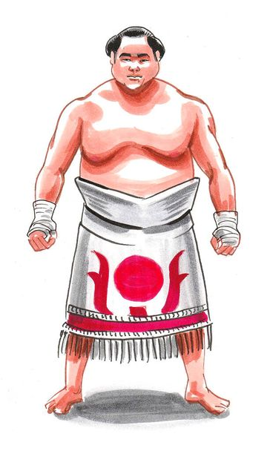

**Tar Mihály Team Sumo Memorial**

**Organizer:** Érdi Spartacus SC and Hungarian Sumo Federation

**Sponsors:** Barta Sándor, Molnár Tamás, Prím Zsolt, Sárosi János,

Ministry of Defence, National Sports Agency of Hungary, Sporting Nation

Details of the   
competition: 22nd September 2024 (Sunday), Batthyány Sportiskolai Általános Iskola Tar Mihály

Wrestling Hall (2030 Érd, Fácán köz 1, Entrance from Pacsirta street)

**Weigh-in:** **22nd September 2024** (Sunday) 8.30-9.00. Medical Certificate is mandatory.

**Start of the   
competition: 22nd September 2024**. 10:15

**Weight   
categories:** Senior man (Born in 2007 and before): 77 kg, 85 kg, 100 kg, 115 kg, +115 kg,

**Entry:** In the team competition, a maximum of 3 teams from each country can participate. These can be national teams or clubs. Hungary is an exception, the organizing team grants free cards to Hungarian clubs. A competitor can only participate in one team. A team must consist of at least 3 members and can have a maximum of 5 members. Every competitor can only compete in their measured weight class.

Registrations should be sent to: erdispartacus@gmail.com

**Deadline for the entries**: **09th September 2024**

**Participation fee: 100.- EUR/teams**

**Details of the competition:** The competition will be held on one dohyo. For up to 5 teams, it will be a round-robin format. If there are more teams, it will be a single-elimination format with double repechage, resulting in two third-place positions. In the event of a tie in the round-robin, another round-robin will take place, again resulting in two third-place positions.

**Equipment:**  Wearing cycling shorts or small shorts is mandatory.

**Referees’:** The referees for the competition are appointed by the Hungarian Sumo Federation.

**Other provisions:** Everyone participates in the competition at their own risk. The organizers of the competition do not take responsibility for any items lost at the competition venue.

**Awards:** 1st place will receive medals, a certificate of honor, and a cash prize of 1,100 EUR

2nd place will receive medals and a cash prize of 750 EUR.

3rd place will receive medals and a cash prize of 375 EUR.

***During the competition, we will be providing sandwiches and refreshments for the teams, coaches, leaders, and after the competition, everyone is invited to a delicious meal cooked in a cauldron.***

Érd, 11.Jun 2024. Sipos Árpád

President

Érdi Spartacus SC